POWER BI CASE STUDY
KPI Calculation Logic
All core KPIs in the dashboard are calculated excluding returned orders to reflect actual business performance.
For example:
- Total Sales = Sales Done − Sales from Returned Orders
- Profit, Margin, and Quantity Sold are also calculated after excluding returned transactions.

Notes
- Due to differences in Power BI versions, the formatting and visual appearance of the dashboard may vary slightly. To address this, relevant snapshots have been included throughout the documentation for reference.
- The dashboard uses the offline Excel file provided with the case study as the data source. To view the Power Query transformations, users may need to update the local file path in the query editor based on their system location.

Overview Page:
- KPI Summary Cards
The top section displays key performance indicators including Total Sales, Total Profit, Total Margin % (Profit / Total Sales), and Sales vs Target achieved to date.
Since 2021 is the latest available year in the dataset, it is considered as the current period for analysis. The cards also show the percentage increase or decrease compared to the previous year.
- Total Sales (Year-over-Year)
This visual shows how total sales have changed over the years, providing a view of overall business performance. Users can analyse trends by applying filters from the left panel, including Segment, Region, and Category.
- Target Achievement Matrix
The “Target Achieved” matrix displays the percentage of sales target achieved across regions and states.
  - Red indicators highlight areas where targets are not achieved.
  - Green indicators highlight areas where targets are met or exceeded.
This helps quickly identify underperforming and high-performing regions.
- Current Profit vs Predicted Profit (Profit Simulator)
This visual acts as a profit simulation tool where users can input different discount levels across segments.
Based on the selected discounts, the dashboard estimates the predicted profit and compares it with the current profit, helping users understand how discount strategies may impact profitability both by segment and overall.
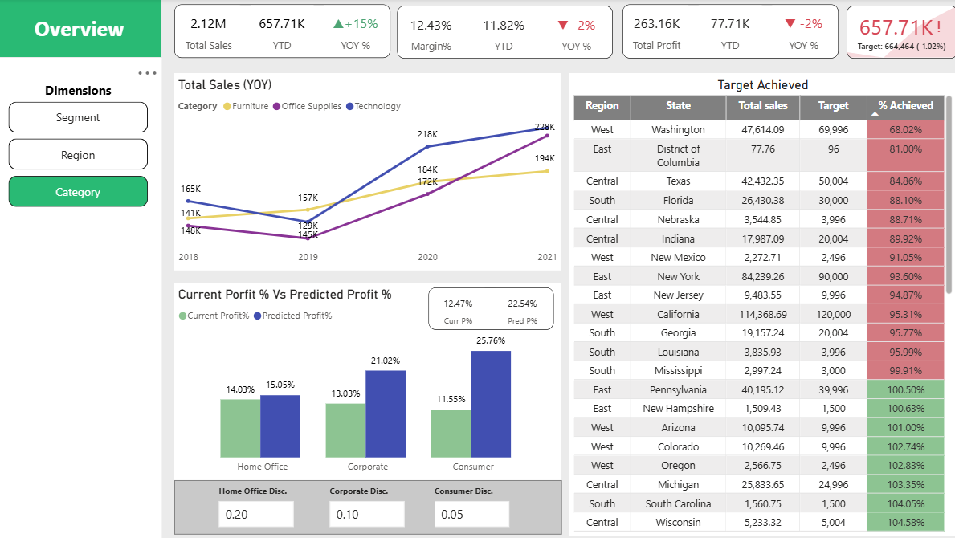

Top Customers Analysis:
- KPI Summary Cards
The top section displays the key performance indicators, similar to those shown on the Overview page.
- Cumulative Sales % – Top 100 Customers
This visual shows the top 100 customers ranked from highest to lowest based on sales. A cumulative percentage line indicates how much these customers contribute to total sales as we move from the highest contributing customer to the 100th customer.
The top-right corner highlights the total cumulative sales contribution made by these top 100 customers compared to overall sales.
- Cumulative Sales Contribution – Top X% Customers
This visual analyze sales contribution based on customer percentage groups. It shows how much cumulative sales are generated by the top X% of customers.
A user input simulator allows users to enter a value for X (from 1% to 100%), dynamically showing the total sales contributed by the top X% of customers.
- Filters for Detailed Analysis
Filters such as Segment, Region, and State are available on the left panel, allowing users to drill down and analyse customer contribution across different business segments and locations.
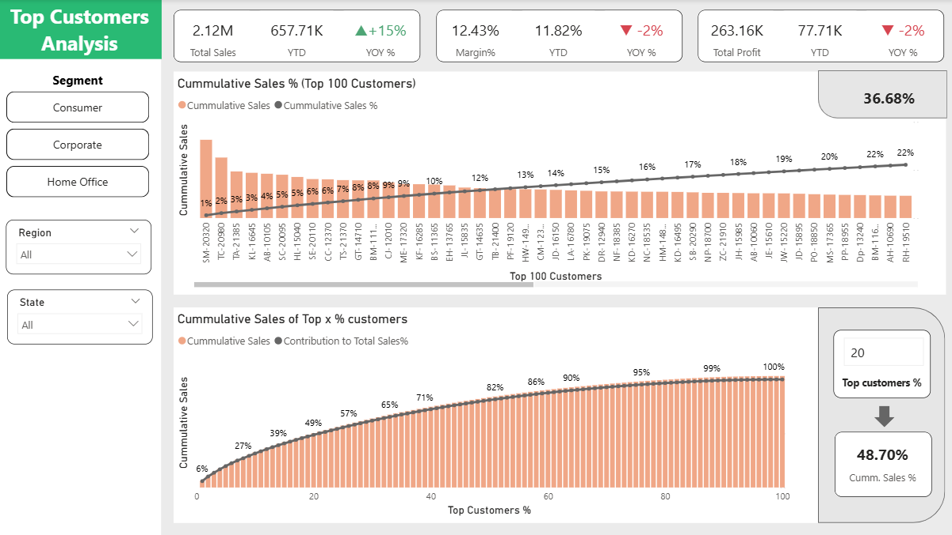

Customer RFM Analysis :

(RFM Analysis is done on last 180 from max date)
- KPI Summary Cards
The top cards display key KPIs for the current year (2021), including number of new customers acquired, total sales generated by these customers, total quantity sold, and the average discount offered. These KPIs provide a quick overview of new customer performance during the year.
- Customer Distribution by Segment / Marketing Tier
The donut chart shows the distribution of customers across different segments and marketing tiers. Customers are classified into High, Medium, and Low value segments, as well as marketing tiers ranging from Platinum (Elite) to Iron (Risky).
The segmentation is based on the RFM model, where customers are evaluated using three scores:
  - Recency (R) – how recently the customer made a purchase
  - Frequency (F) – how often the customer makes purchases
  - Monetary (M) – how much the customer spends
These scores are calculated using data from the last 180 months from the maximum available date, and combined to generate an overall RFM score. Based on this score and business logic, customers are assigned to different segments and marketing tiers to support targeted marketing strategies.
- Total Sales by Customer Segment / Marketing Tier
This visual shows the sales contribution from each customer segment or marketing tier. The bars represent the total sales generated by each segment, while the line indicates the percentage contribution of each segment to overall sales.
- Repeat Customers Trend
This line chart shows the percentage of returning customers over the years, indicating how many existing customers continue to make purchases in subsequent years. It helps track customer retention and loyalty trends.
- Frequency vs Monetary Distribution
The scatter plot represents individual customers based on their Frequency and Monetary values.
  - The top-right quadrant represents high-value customers with both high purchase frequency and high spending, which are the most desirable customers.
  - The bottom-left quadrant represents low-value customers with low frequency and lower total spending.
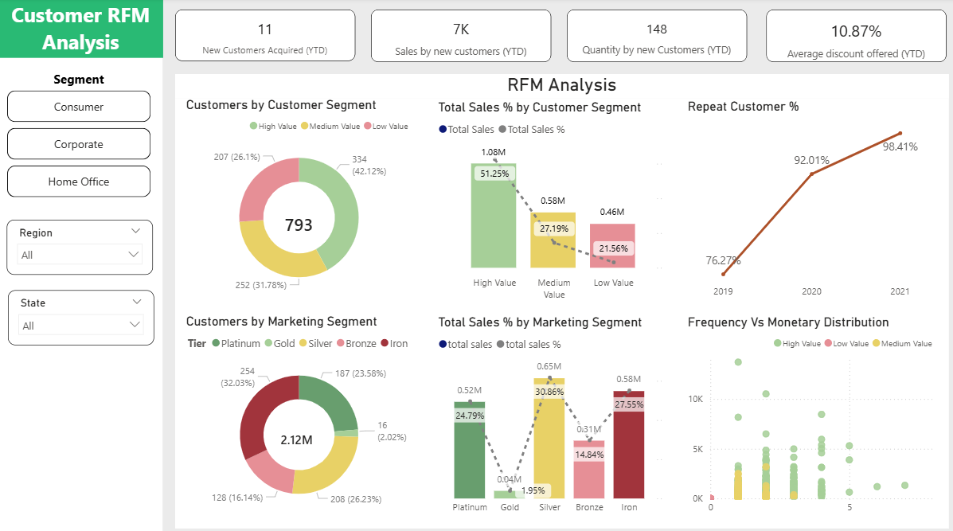

Top Salesperson Analysis:

(The analysis is only for current year i.e. 2021 in this case)
- KPI Summary Cards
The top cards highlight the contribution of the top 5 salespersons to overall business performance. These KPIs show their total sales contribution, quantity sold, and average discount offered, providing a quick view of the performance of the highest-performing sales representatives.
- Top 5 Salesperson Performance
The stacked bar chart displays the top 5 salespersons based on total sales generated to date. The stacked segments within each bar show the distribution of sales across different product segments, allowing users to understand which segments contribute most to each salesperson’s performance.
- Discount vs Total Sales
The scatter plot compares discount offered and total sales generated for the top 50 salespersons. This helps analyze the relationship between discount strategies and sales performance.
Ideally, higher sales with lower discounts indicate more efficient sales performance.
- Top 5 Salesperson – Detailed View (Deep Dive)
This section provides a detailed breakdown of the top 5 salespersons, including their total sales and average discounts offered, with further analysis available at the state and city levels.
Users can also apply the segment filter to analyze performance across specific product segments.
